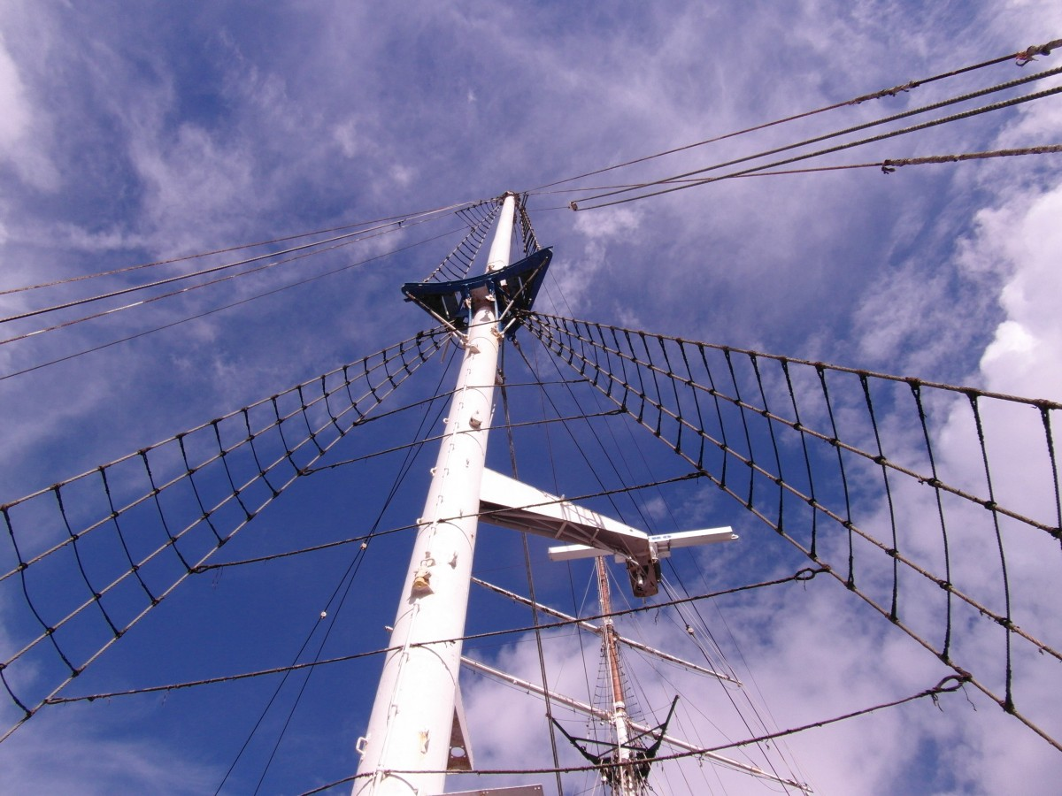  Basic  Electricity    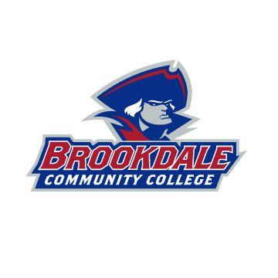  Course | Course Info  TUESDAYS  JUNE 7TH -AUGUST 9TH  6:00PM-9:00PM  Online Via Zoom
Registration
Call:
(732) 224-2315
Email: cps@brookdalecc.edu

Fee: $659
Code: XBUSD-090-JUC01

ABOUT THE COURSE

This course covers electrostatics, direct current electricity, magnetism, magnetic induction, alternating current electricity, light and optics. The course content will also include all the following:

- The Nature of Electricity; Electrical Standards and Conventions
- Ohm’s Law and Power
- Direct Current Series Circuits
- Direct Current Parallel Circuits: Batteries
- Three Phase Transformer Connection
- Three Phase Systems
- Single Phase Transformer,
- Single Phase Circuits,
- Inductance and Capacitive Circuits
- Kirchhoff’s Laws, Thevenin’s Theorem, Series/Parallel Circuits
- Line Drop Calculations, Three Wire Systems
- Magnetism and Electromagnetism
- Principles of Alternating Current

